Task 10-Box Model (Gemini)

**The CSS Box Model**

The CSS box model is a conceptual representation of how elements are laid out on a web page. It consists of four main components:

1. **Content:** The area that contains the actual content of the element (text, images, etc.).
2. **Padding:** The space between the content and the border.
3. **Border:** The outline that surrounds the content and padding.
4. **Margin:** The space outside the border, separating the element from other elements.

**Example HTML and CSS**

<!DOCTYPE html>

<html>

<head>

<title>Box Model Example</title>

<style>

.box {

    width: 200px;

    height: 200px;

    border: 2px solid black;

    padding: 20px;

    margin: 20px;

}

</style>

</head>

<body>

<div class="box">This is a box</div>

</body>

</html>

**Visual Examples**

**Changing Padding:**

[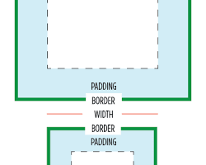Opens in a new window[](https://css-tricks.com/almanac/properties/b/box-sizing/)css-tricks.com](https://css-tricks.com/almanac/properties/b/box-sizing/)

box with different padding values

Increasing the padding value creates more space between the content and the border, making the element appear larger without affecting its width or height.

**Changing Margin:**

[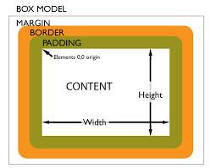Opens in a new window[](https://mustbebuilt.co.uk/html-css-material/box-model.php)mustbebuilt.co.uk](https://mustbebuilt.co.uk/html-css-material/box-model.php)

box with different margin values

Increasing the margin value creates more space between the element and other elements on the page, affecting the overall layout.

**Changing Border:**

[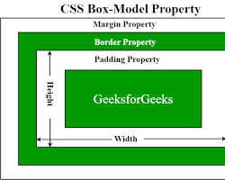Opens in a new window[](https://www.geeksforgeeks.org/css-box-model/)www.geeksforgeeks.org](https://www.geeksforgeeks.org/css-box-model/)

box with different border values

Modifying the border width, style, or color can change the appearance of the element's outline.

**Understanding the Box Model**

It's important to understand how these components interact to create the final layout. The total width and height of an element are calculated as follows:

Total width = width + padding-left + padding-right + border-left + border-right + margin-left + margin-right;

Total height = height + padding-top + padding-bottom + border-top + border-bottom + margin-top + margin-bottom;

By understanding the box model and its components, you can effectively control the layout and spacing of elements on your web pages.